Website Report for d32-dentistry.business.site



The HOTH

111 2nd Ave NE, Suite 1500, St. Petersburg, FL 33701

877-720-4684

[support@thehoth.com](mailto:support@thehoth.com)

[thehoth.com](http://thehoth.com/)

This report grades your website based on the strength of various SEO factors such as On Page Optimization, O Page Links, Social and more. The overall Grade is on a A+ to F- scale, with most major, industry leading websites in the A range. Improving your grade will generally make your website perform better for users and rank better in search engines. There are recommendations for improving your website at the bottom of the report. Feel free to reach out to us if you’d like us to help with improving your website’s SEO!

Audit Results for d32-dentistry.business.site



**B**

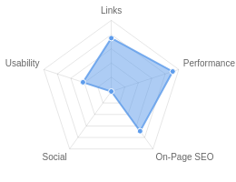**Your page could be better**

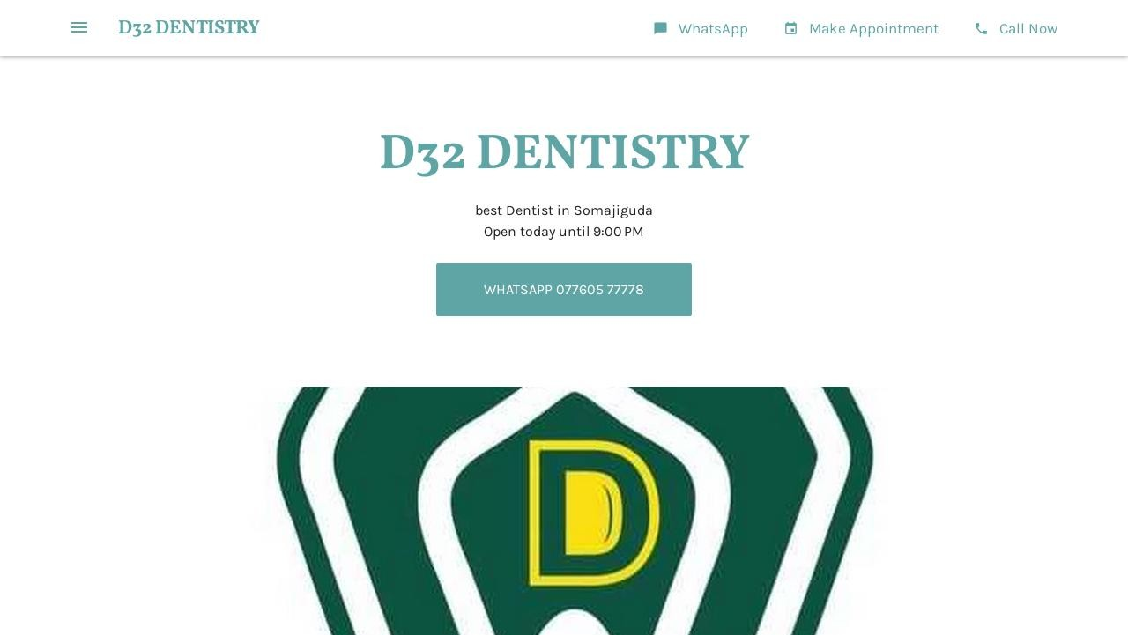

Recommendations: 17



**B+**



**A-**



**C**



**A+**



**F**

On-Page SEO

Links

Usability

Performance

Social

Recommendations

# Include a meta description tag

On-Page SEO

High Priority

**Update Link URLs to be more human and Search Engine readable**

Links

Low Priority

# Add Alt attributes to all images

On-Page SEO

Low Priority

**Use your main keywords across the important HTML tags**

On-Page SEO

Low Priority

# Increase page text content

On-Page SEO

Low Priority

**Create and link your Facebook Page**

Social

Low Priority

# Create and link your Twitter profile

Social

Low Priority

**Optimize your page for Mobile PageSpeed Insights**

Usability

Low Priority

# Optimize your page for Desktop PageSpeed Insights

Usability

Low Priority

**Add Twitter Cards**

Social

Low Priority

# Add a favicon

Usability

Low Priority

**Setup & Install a Facebook Pixel**

Social

Low Priority

# Remove inline styles

Performance

Low Priority

**Create and link associated Instagram profile**

Social

Low Priority

# Create and link an associated YouTube channel

Social

Low Priority

**Create and link an associated LinkedIn profile**

Social

Low Priority

# Create Google Business Profile

Other

Low Priority

On-Page SEO Results

**Your On-Page SEO could be better**



**B+**

Your page has some level of On-Page SEO optimization but could be improved further. On-Page SEO is important to ensure Search Engines can understand your content appropriately and help it rank for relevant keywords. You should ensure that HTML Tag Content is completed correctly and align text content to target keywords.

# Title Tag

You have a title tag of optimal length (between 10 and 70 characters). D32 DENTISTRY - best Dentist in Somajiguda

Length : 42

# Meta Description Tag

Your page appears to be missing a meta description tag.

A meta description is important for search engines to understand the content of your page, and is often shown as the description text blurb in search results.

# SERP Snippet Preview

This illustrates how your page may appear in Search Results. Note, this is intended as a guide and Search Engines are more frequently generating this content dynamically.

https://d32-dentistry.business.site ⋮

D32 DENTISTRY - best Dentist in Somajiguda

best Dentist in Somajiguda

# Hreflang Usage

Your page is not making use of Hre ang attributes.

# Language

Your page is using the lang attribute. Declared: en-US

# H1 Header Tag Usage

Your page has a H1 Tag.

# H2-H6 Header Tag Usage

Your page is making use multiple levels of Header Tags.

Header Tag Frequency

H2 4

H3 3

H4 0

H5 0

H6 0

# Keyword Consistency

Your page's main keywords are not distributed well across the important HTML tags.

Your page content should be focused around particular keywords you would like to rank for. Ideally these keywords should also be distributed across tags such as the title, meta and header tags.

Individual Keywords

Keyword Title Meta Description

Tag

Headings Tags Page Frequency

dentistry    7

d32    7

dental    7

call    6

now    6

smile    4

posted    4

very    4

Phrases

Phrase Title Meta Description

Tag

d32 dentistry    7

Headings Tags Page Frequency

call now    6

am 900    6

am 900 pm    6

at d32    3

now posted    3

ago    3

posted on sep    3

# Amount of Content

Your page has a low volume of text content which search engines can interpret as 'thin content'.

Word Count: 455

It has been well researched that higher text content volumes are related to better ranking ability in general.

# Image Alt Attributes

You have images on your page that are missing Alt attributes.

We found 10 images on your page and 9 of them are missing the attribute.

Alt attributes are an often overlooked and simple way to signal to Search Engines what an image is about, and help it rank in image search results.

# Canonical Tag

Your page is using the Canonical Tag.

https://d32-dentistry.business.site

# Noindex Tag Test

Your page is not using the Noindex Tag which prevents indexing.

# Noindex Header Test

Your page is not using the Noindex Header which prevents indexing.

# SSL Enabled

Your website has SSL enabled.

# HTTPS Redirect

Your page successfully redirects to a HTTPS (SSL secure) version.

# Robots.txt

Your website appears to have a robots.txt le.

<http://d32-dentistry.business.site/robots.txt>

# Blocked by Robots.txt

Your page does not appear to be blocked by robots.txt.

# XML Sitemaps

Your website appears to have an XML sitemap.

<http://d32-dentistry.business.site/sitemap.xml>

# Analytics

Your page is using an analytics tool.



Google Analytics

# Schema.org Structured Data

You are using Microdata Schema on your page.

Rankings

# Keyword Positions

This shows you a summary of the positions for your Keyword Rankings. The higher you rank, the more likely you are to capture tra c, with recent research showing that as much as 92% of clicks happen on the rst page.

|  |  |
| --- | --- |
| Position | Keywords |
| Position 1 | 0 |
| Position 2-3 | 0 |
| Position 4-10 | 0 |
| Position 11-20 | 0 |
| Position 21-30 | 0 |
| Position 31-100 | 0 |

Links

# Backlink Summary

You have a very strong level of backlink activity to this page.



**94**



**24**

Domain Strength

Page Strength





**0**

Backlinks

**0**

Referring Domains

|  |  |  |  |  |  |
| --- | --- | --- | --- | --- | --- |
| **0**  Nofollow Backlinks | **0**  Dofollow Backlinks | **0**  Edu Backlinks | **0**  Gov Backlinks | **0**  Subnets | **0**  IPs |

# Top Backlinks

We haven't found any backlinks to report for this site.

# Top Pages by Backlinks

We haven't found any Top Pages data for this site.

# Top Anchors by Backlinks

We haven't found any Anchor Text data for this site.

# Top Referring Domain Geographies

We haven't found any Geographic Data for this site.

# On-Page Link Structure

We found 30 total links. 60% of your links are external links and are sending authority to other sites. 0% of your links are nofollow links, meaning authority is not being passed to those destination pages.

# Friendly Links

Some of your link URLs do not appear friendly to humans or search engines.

We would recommend making URLs as readable as possible by reducing length, le names, code strings and special characters.

Usability

# Your usability could be better



**C**

Your page is OK but could be more usable across devices. Usability is important to maximize your available audience and minimize user bounce rates (which can indirectly a ect your search engine rankings).

# Device Rendering

This check visually demonstrates how your page renders on di erent devices. It is important that your page is optimized for mobile and tablet experiences as today the majority of web tra c comes from these sources.

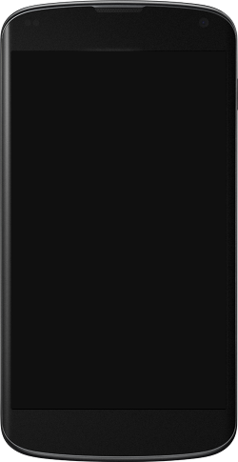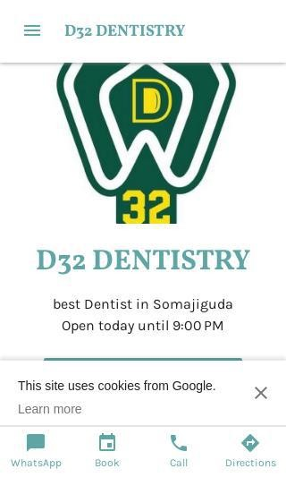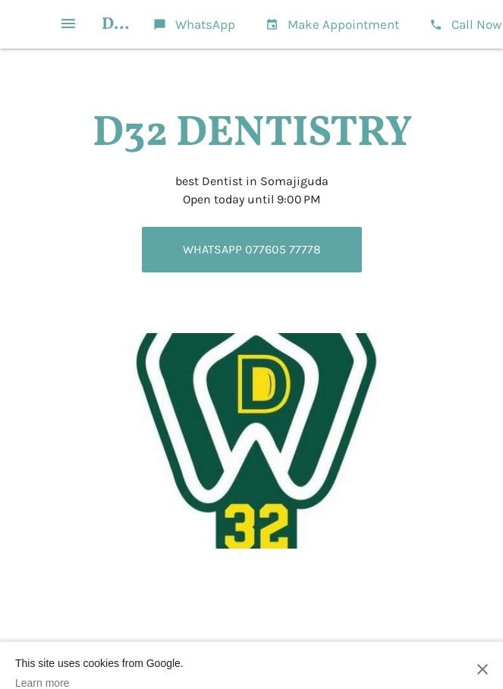

# Google's Core Web Vitals

Google is indicating that they do not have 'su cient real-world speed data for this page' in order to make a Core Web Vitals assessment. This can occur for smaller websites or those that are not crawl- able by Google.

# Use of Mobile Viewports

Your page speci es a viewport matching the device's size, allowing it to render appropriately across devices.

# Google's PageSpeed Insights - Mobile

Google is indicating that your page is scoring poorly on their Mobile PageSpeed Insights evaluation.

Note that this evaluation is being performed from US servers and the results may di er slightly from an evaluation carried out from Google's PageSpeed Web Interface as that reporting localizes to the region in which you are running the report.

Google has indicated that the performance of a webpage is becoming more important from a user and subsequently ranking perspective.



**40**

Lab Data Value

First Contentful Paint 4.1 s

Opportunities Estimated Savings

Speed Index 4.1 s

Largest Contentful Paint 5.5 s

Time to Interactive 6.6 s

Eliminate render-blocking resources

Serve images in next-gen

formats

3.15 s

2.65 s

Total Blocking Time 0.47 s

Reduce unused JavaScript 1.65 s

Cumulative Layout Shift 0.62

Properly size images 1.05 s

Avoid multiple page redirects 0.63 s

Defer o screen images 0.75 s

# Google's PageSpeed Insights - Desktop

Google is indicating that your page is scoring poorly on their Desktop PageSpeed Insights evaluation.

Google has indicated that the performance of a webpage is becoming more important from a user and subsequently ranking perspective.



**81**

Lab Data Value

First Contentful Paint 1.1 s

Opportunities Estimated Savings

Speed Index 1.1 s

Largest Contentful Paint 2.1 s

Time to Interactive 1.5 s

Serve images in next-gen formats

Properly size images

1.08 s

Eliminate render-blocking

resources

0.64 s

0.72 s

Total Blocking Time 0.02 s

Cumulative Layout Shift 0.218

Reduce unused JavaScript 0.24 s

Avoid multiple page redirects 0.19 s

|  |  |  |
| --- | --- | --- |
| **Flash Used?**  No Flash content has been identi ed on your page. |  | |
| **iFrames Used?**  There are no iFrames detected on your page. |  |  |
| **Favicon**  We have not identi ed a favicon on your page. |  |  |

Favicons are a way to increase brand visibility and make your page more recognizable when browsing amongst multiple browser tabs or bookmarks.

# Email Privacy

No email addresses have been found in plain text on your page.

# Legible Font Sizes

The text on your page appears to be legible across devices.

# Tap Target Sizing

The links and buttons on your page appear to be appropriately sized for a user to easily tap on a touchscreen.

Performance Results

# Your performance is very good!



**A+**

Congratulations, your page has performed very well in our testing meaning it should be reasonably fast and responsive for users. Performance is important to ensure a good user experience, and reduced bounce rates (which can also indirectly a ect your search engine rankings). Continue to monitor your performance over time to ensure there are no periodic uctuations.

# Page Speed Info

Your page loads in a reasonable amount of time.

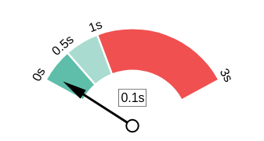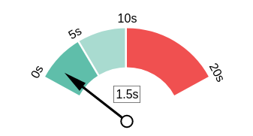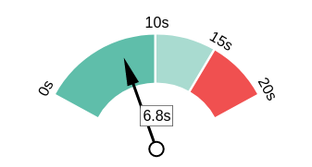Server Response All Page Content Loaded All Page Scripts Complete

# Download Page Size

Your page's le size is reasonably low which is good for Page Load Speed and user experience.

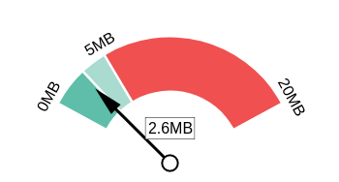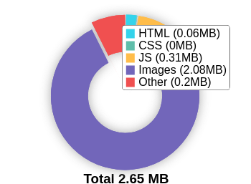Download Page Size Download Page Size Breakdown

# Website Compression (Gzip, Deflate, Brotli)

Your website appears to be using a reasonable level of compression.

Compression Rates Raw Page Size Breakdown

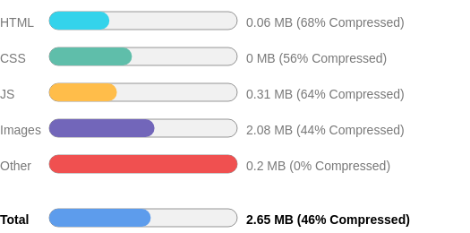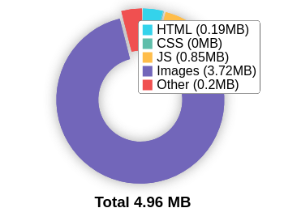

# Number of Resources

This check displays the total number of les that need to be retrieved from web servers to load your page.



63

Total Objects

2

Number of HTML Pages

13

Number of JS Resources

2

Number of CSS Resources

38

Number of Images

8

Other Resources

# Google Accelerated Mobile Pages (AMP)

This page does not appear to have AMP Enabled.

# JavaScript Errors

Your page is not reporting any JavaScript errors.

# HTTP2 Usage

Your website is using the recommended HTTP/2+ protocol.

# Optimize Images

All of the images on your page appear to be optimized.

# Minification

All your JavaScript and CSS les appear to be mini ed.

# Deprecated HTML

No deprecated HTML tags have been found within your page.

# Inline Styles

Your page appears to be using inline styles.

Inline styles are an older coding practice and discouraged in favor of using CSS style sheets, due to their ability to degrade page load performance and unnecessarily complicate HTML Code.

Social Results

# Your social needs improvement



**F**

You appear to have a weak social presence or level of social activity (or we may just not be able to see your pro les!). Social activity is important for customer communication, brand awareness and as a marketing channel to bring visitors to your website. We recommend that you list all of your pro les on your page for visibility, and begin to build a following on those networks.

# Facebook Connected

No associated Facebook Page found as a link on your page.

# Facebook Open Graph Tags

Your page is using Facebook Open Graph Tags.

# Facebook Pixel

We have not detected a Facebook Pixel on your page.

Facebook's Pixel is a useful piece of analytics code that allows you to retarget visitors if you decide to run Facebook Ads in future.

# Twitter Connected

No associated Twitter pro le found as a link on your page.

# Twitter Activity

No associated Twitter pro le found as a link on your page.

# Twitter Cards

We have not detected Twitter Cards on your page.

Twitter Cards are a type of structured data that can be placed on your page to control what content is shown when a page is shared on Twitter.

# Instagram Connected

No associated Instagram pro le found linked on your page

# LinkedIn Connected

No associated LinkedIn pro le found linked on your page.

# YouTube Connected

No associated YouTube channel found linked on your page.

# YouTube Activity

No associated YouTube channel found linked on your page.

Local SEO

# Address & Phone Shown on Website

Address and phone number visible on the page.

Phone +1 07760577778

Address D.NO 6-3-927;GROUND FLOOR

Raj Bhavan Road

beside INDIANOIL PETROL BUNK

Somajiguda

Hyderabad, Telangana 500082 India

<

# Local Business Schema

Local Business Schema identi ed on the page.

LocalBusiness

# Google Business Profile Identified

No Google Business Pro le was identi ed that links to this website.

# Google Business Profile Completeness

No Google Business Pro le was identi ed that links to this website.

# Google Reviews

No Google Business Pro le was identi ed that links to this website.

Technology Results

# Technology List

These software or coding libraries have been identi ed on your page.

Technology Version



Google Analytics

 Google Call Conversion Tracking



Google My Business

HTTP/3

# Server IP Address

142.251.46.238

# DNS Servers

b.nic.site a.nic.site e.nic.site f.nic.site

# Web Server

ESF

# Charset

text/html; charset=utf-8